**APPENDIX I**

**Travalicious - An Ecommerce website**

**A PROJECT REPORT**

***Submitted by***

# YUVRAJ PRATAP SINGH

***in partial fulfillment for the award of the degree***

***of***

# BACHELOR OF TECHNOLOGY

**IN**

## COMPUTER SCIENCE AND ENGINEERING



# Lovely Professional University, Punjab

**ENROLENMENT NUMBER**

**12410511**

**October 2024**

**APPENDIX II**

**Lovely Professional University, Punjab**

**BONAFIDE CERTIFICATE**

Certified that this project report “**TRAVELICIOUS-Ecommerce website**”

is the Bonafide work of “**YUVRAJ SINGH**”

who carried out the project work under my supervision

**SIGNATURE** **SIGNATURE**

**CLASS MENTOR SUPERVISOR**

**APPENDIX III**

### TABLE OF CONTENTS

|  |  |  |
| --- | --- | --- |
| **CHAPTER**  **NO.** | **CHAPTER NAME** | **PAGE NO.** |
| **1** | **Title Page** | **i** |
| **2** | **Bonafide Certificate** | **ii** |
| **3** | **Abstract** | **iv** |
| **4** | **List of Symbols, Abbreviations and Nomenclature** | **5** |
| **5** | **Chapter 1** | **6** |
| **6** | **Chapter 2** | **8** |
| **7** | **github link** | **26** |

**ABSTRACT**

**Book and Cook website connects users with local restaurants, allowing them to browse menus, place orders, and get food delivered to their location.** **Customers can search for restaurants, view menus, customize orders, and make secure payments. Real-time order tracking.** **The system notifies restaurants and delivery personnel about new orders.** **Secure payment options like credit cards, digital wallets, and cash on delivery.**

# APPENDIX IV

**LIST OF FIGURES**

|  |  |  |
| --- | --- | --- |
| **Sr. No** | **Detail** | **PAGE NO.** |
| **1** | **signup page** | **19** |
| **2** | **login page** | **20** |
| **3** | **home page** | **21** |
| **4** | **cart page** | **24** |
| **5** | **contact page** | **25** |

# Chapter 1

**Introduction:**

Travelicious website is a user-friendly platform designed to simplify travel planning and enhance exploration. It provides detailed information about destinations, booking options for flights, hotels, and activities, along with personalized itinerary tools. Featuring user reviews and travel blogs, it helps travelers make informed decisions. Cost comparison tools and exclusive deals ensure budget-friendly options. The platform inspires wanderlust with rich content, including photos, guides, and cultural insights. Its interactive interface connects users to a global travel community for shared experiences and advice. By integrating convenience, personalization, and accessibility, the website transforms trip planning into an effortless and enjoyable experience.

**Overview:**

The traveling website is a comprehensive platform aimed at streamlining travel planning and enhancing user experiences. It offers detailed destination guides, booking options for flights, accommodations, and activities, and tools for creating personalized itineraries. Users can explore travel blogs, reviews, and ratings to make well-informed decisions. Cost comparison features and exclusive deals ensure affordability. The website also includes interactive elements like forums and chat options to connect travelers worldwide. With its visually appealing interface, it inspires exploration and helps users discover new destinations. This project is designed to make travel planning convenient, efficient, and enjoyable for all users.

**Technical Design and Responsiveness:**

* The site is designed using HTML for structure and CSS for styling, demonstrating the power of front-end languages to build a visually appealing, functional interface.
* Interactive CSS animations and effects add to the website's modern look, contributing to a more engaging user experience.
* The responsive layout ensures functionality across different devices, aligning with current web design standards for accessibility.

## 

## Chapter 2

**HTML CODE:**

**Home page:**

The following is the HTML code which is used for the home page of this website:

<!DOCTYPE html>

<html lang="en">

 <head>

    <meta charset="UTF-8">

    <meta http-equiv="X-UA-Compatible" content="IE=edge">

    <meta name="viewport" content="width=device-width, initial-scale=1.0">

    <title>login page | Madhav </title>

    <link rel="stylesheet" href="styleloginpage.css">

 </head>

 <body>

    <div class="wrapper">

        <form action="">

            <h1>Login</h1>

            <div class="input-box">

                <input type="text" placeholder="Username" required>

                <i class='bx bxs-user' ></i>

            </div>

            <div class="input-box">

                <input type="password" placeholder="Password" required>

                <i class='bx bxs-lock-alt'></i>

            </div>

            <div class="remember-forget">

                <label><input type="checkbox"> Remember-me</label>

                <a href="#">Forgot password ?</a>

            </div>

            <button type="submit" class="btn">Login</button>

            <div class="register-link">

                <p>Don't have an account ? <a href="#">Register</a></p>

            </div>

        </form>

    </div>

 </body>

**login page:**

The following is the HTML code which is used for the login page of this website:

<!DOCTYPE html>

<html lang="en">

<head>

    <meta charset="UTF-8">

    <meta name="viewport" content="width=device-width, initial-scale=1.0">

    <title>login</title>

</head>

<body>

    <!DOCTYPE html>

<html lang="en">

<head>

    <meta charset="UTF-8">

    <meta name="viewport" content="width=device-width, initial-scale=1.0">

    <title>Document</title>

</head>

<body style="background-color: beige">

    <center><div><img src="LOGO.png" alt="book and cook logo"></div></center>

    <div style="margin-top: 50px;text-align: center;background-color:rgb(105, 18, 18);margin-left: 600px;margin-right: 600px;border-radius: 5%;padding: 10px;border: 2px solid black;">

        <form id="myform" action="homepage.html">

            <div class="message" id="nameMessage"></div> <br> <br>

            <label for="email">Email</label>

            <input type="email" id="email" onkeyup="validateEmail()" required> <br> <br>

            <div class="message" id="EmailMessage"></div>

            <label for="password">Password</label>

            <input type="password" id="password" onkeyup="validatePassword()" required> <br> <br>

            <div class="message" id="passwordMessage"></div>

            <input type="submit" value="Submit form">

           </form> </div>

           <script src="login.js">

           </script>

</body>

</html>

</body>

</html>

**signup page:**

The following is the HTML code which is used for the signup page of this website:

<!<!DOCTYPE html>

<html lang="en">

 <head>

    <meta charset="UTF-8">

    <meta http-equiv="X-UA-Compatible" content="IE=edge">

    <meta name="viewport" content="width=device-width, initial-scale=1.0">

    <title>login page | Madhav </title>

    <link rel="stylesheet" href="styleloginpage.css">

 </head>

 <body>

    <div class="wrapper">

        <form action="">

            <h1>Login</h1>

            <div class="input-box">

                <input type="text" placeholder="Username" required>

                <i class='bx bxs-user' ></i>

            </div>

            <div class="input-box">

                <input type="password" placeholder="Password" required>

                <i class='bx bxs-lock-alt'></i>

            </div>

            <div class="remember-forget">

                <label><input type="checkbox"> Remember-me</label>

                <a href="#">Forgot password ?</a>

            </div>

            <button type="submit" class="btn">Login</button>

            <div class="register-link">

                <p>Don't have an account ? <a href="#">Register</a></p>

            </div>

        </form>

    </div>

 </body>

**contact page:**

The following is the HTML code which is used for the contact page of this website:

<!DOCTYPE html>

<html lang="en">

<head>

    <meta charset="UTF-8">

    <meta name="viewport" content="width=device-width, initial-scale=1.0">

    <title>Virtual Classroom and E=Learning Platform</title>

    <link rel="stylesheet" href= "about.css" >

    <link rel="stylesheet" href= "style.css" >

    <link rel="stylesheet" href= "contact.css" >

    <!--ICONSCOUT CDN-->

    <link rel="stylesheet" href="https://unicons.iconscout.com/release/v4.0.8/css/line.css">

     <!--Goggle font-->

     <link rel="preconnect" href="https://fonts.googleapis.com">

     <link rel="preconnect" href="https://fonts.gstatic.com" crossorigin>

     <link href="https://fonts.googleapis.com/css2?family=Montserrat:wght@300;400;500;700;800;900&display=swap" rel="stylesheet">

     <!-- swiper js -->

     <link rel="stylesheet" href="https://cdn.jsdelivr.net/npm/swiper@11/swiper-bundle.min.css"/>

    <section class="contact">

        <div class="container contact__container">

            <aside class="contact__aside">

                <div class="aside__image">

                    <img src="contact.png">

                </div>

                <h2>Contact US</h2>

                <p>Connect with us seamlessly. Whether you have inquiries, feedback, or collaboration ideas, our contact page is your gateway. Reach out for personalized support and embark on a journey with us</p>

                <ul class="contact__details">

                    <li>

                        <i class="vil uil-phone-times"></i>

                        <h5>+91 9056713305</h5>

                    </li>

                    <li>

                        <i class="vil uil-envelope"></i>

                        <h5>support@wstech.com</h5>

                    </li>

                    <li>

                        <i class="vil uil-location-point"></i>

                        <h5>Phagwera ,Punjab,India</h5>

                    </li>

                </ul>

                <ul class="contact__socials">

                    <li>

                        <a href="https://facebook.com"><i class="vil uil-facebook-f"></i></a>

                    </li>

                    <li>

                        <a href="https://instagram.com"><i class="vil uil-instagram"></i></a>

                    </li>

                    <li>

                        <a href="https://twitter.com"><i class="vil uil-twitter"></i></a>

                    </li>

                    <li>

                        <a href="https://linkedin.com"><i class="vil uil-linkedin-alt"></i></a>

                    </li>

                </ul>

            </aside>

            <form class="contact__form" action="https://formspree.io/f/mrgwwedw" method="POST">

                <div class="form__name">

                    <input type="text" name="First Name" placeholder="First Name" required>

                    <input type="text" name="Last Name" placeholder="Last Name" required>

                </div>

                <input type="email" name="Email Address" placeholder="Enter your email Address" required>

                <textarea name="Message" rows="7" required placeholder="Message"></textarea>

                <button type="submit" class="btn btn-primary">Send Message</button>

            </form>

        </div>

    </section>

    </body>

    </html>

**CSS CODE:**

The following is the CSS code snippet used for designing the website

@import url("https://fonts.googleapis.com/css2?family=Dancing+Script:wght@600&family=Lora:wght@500;600&family=Poppins:wght@400;500&display=swap");

:root {

  --header-height: 4.5rem;

  --first-color: hsl(243, 80%, 48%);

  --first-color-alt:  hsl(243, 49%, 78%);

  --title-color: hsl(0, 0%, 4%);

  --text-color: hsl(0, 0%, 0%);

  --text-color-light: hsl(206, 100%, 48%);

  --container-color: rgba(7, 7, 7, 0.2);

  --body-font: "Poppins", sans-serif;

  --title-font: "Lora", serif;

  --subtitle-font: "Dancing Script", cursive;

  --biggest-font-size: 3.25rem;

  --h1-font-size: 2.5rem;

  --h2-font-size: 2.25rem;

  --h3-font-size: 1rem;

  --normal-font-size: .938rem;

  --small-font-size: .813rem;

  --smaller-font-size: .75rem;

  --font-medium: 500;

  --font-semi-bold: 600;

  --z-tooltip: 10;

  --z-fixed: 100;

}

* {

  box-sizing: border-box;

  padding: 0;

  margin: 0;

}

html {

  scroll-behavior: smooth;

}

body {

  background-color: red;

  background: url('eureka.jpg') no-repeat;

  background-size: cover;

  font-family: var(--body-font);

  font-size: var(--normal-font-size);

  background-color: var(--body-color);

  color: var(--text-color);

  transition: background .4s; }

h1, h2, h3 {

  color: var(--title-color);

  font-weight: var(--font-medium);

}

ul {

  list-style: none;

}

a {

  text-decoration: none;

}

img {

  max-width: 100%;

  height: auto;

}

.nav__buttons{

  display: flex;

  align-items: center;

  column-gap: 1rem;

}

.change-theme{

  font-size: 1.25rem;

  color: var(--title-color);

  cursor: pointer;

  transition: color .3s;

}

.container {

  width:1024px;

  margin-inline: 1.5rem;

}

.grid {

  display: grid;

  gap: 1.5rem;

}

.section {

  padding-block: 5rem 1rem;

}

.section__subtitle {

  display: block;

  font-size: var(--h2-font-size);

  font-family: var(--subtitle-font);

  color: var(--first-color);

  margin-bottom: 0.5rem;

}

.section__title,

.section__subtitle {

  text-align: center;

}

.nav__logo,

.nav__toggle,

.nav__close{

  display: flex;

  color: var(--title-color);

}

.main {

  overflow: hidden;

}

.header{

  position: fixed;

  width: 100%;

  background-color: var(--body-color);

  top: 0;

  left: 0;

  z-index: var(--z-fixed);

  transition: box-shadow .3s, background .4s;

}

.nav{

  position: relative;

  height: var(--header-height);

  display: flex;

  justify-content: space-between;

  align-items: center;

}

.nav__logo{

  align-items: center;

  column-gap: 3cap;

  font-family: var(--title-font);

  font-size: var(--h3-font-size);

  font-weight: var(--font-semi-bold);

  transition: color .3s;

}

.nav__logo img{

  width: 50px;

}

.nav__logo:hover{

  color: var(--first-color);

}

.nav__toggle{

  font-size: 1.25rem;

  cursor: pointer;

}

@media screen and (max-width: 767px){

  .nav__menu{

    position: fixed;

    top: -100%;

    left: 0;

    background-color: var(--body-color);

    width: 100%;

    box-shadow: 0 8px 20px hsl(122, 16%, 15%);

    padding-block: 3.5rem;

    transition: top .4s;

  }

}

.nav__list{

  display: flex;

  flex-direction: column;

  text-align: center;

  row-gap: 2rem;

}

.section__title {

  font-size: var(--h1-font-size);

  font-family: var(--title-font);

  margin-bottom: 1.5rem;

}

.nav__link:hover{

  color: var(--first-color);

}

.nav__close{

  position: absolute;

  top: 1rem;

  right: 1.5rem;

  font-size: 1.5rem;

  cursor: pointer;

}

.nav__img-1,

.nav__img-2{

  position: absolute;

  opacity: .2;

}

.nav__img-1{

  width: 100px;

  top: .75rem;

  left: -2rem;

  transform: rotate(165deg);

}

.nav__link{

  color: var(--title-color);

  font-weight: var(--font-medium);

  transition: color .4s;

}

.nav__img-2{

  width: 50px;

  right: -1rem;

  bottom: 0;

  transform: rotate(-30deg);

}

.bg-header{

  box-shadow: 0 2px 8px hsla(122, 64%,24%, .1);

}

.active-link{

    color: var(--first-color);

}

.home__container{

  row-gap: 3rem;

  padding-top: 2rem;

}

.home__img{

  width: 500px;

  height: 500px;

  justify-self:center;

}

.home__data{

  text-align: center;

}

.home{

  position: relative;

}

.home__title{

  font-size: var(--biggest-font-size);

  font-family: var(--title-font);

  margin-bottom: 1rem;

}

.home__title img{

  width: 40px;

}

.home__title div{

  display: flex;

  align-items: center;

  justify-content: center;

  column-gap: .5rem;

}

.home1,

.home2{

  position: absolute;

  opacity: .2;

}

.home1{

  width: 80px;

  top: 8rem;

  left: -1rem;

  transform: rotate(90deg);

}

.home2{

  width: 100px;

  right: -2rem;

  bottom: 1rem;

  transform: rotate(-15deg);

}

.button{

  display: inline-flex;

  align-items: center;

  column-gap: .5rem;

  background-color: var(--first-color);

  padding: 1rem 1.5rem;

  border-radius: 4rem;

  color: #fff;

  font-weight: var(--font-medium);

  transition: background .3s;

}

.home__description{

  padding: 0 1rem;

  margin-bottom: 2.5rem;

}

.button i{

  font-size: 1.5rem;

  transition: transform .3s;

}

.button:hover i{

  transform: translateX(.25rem);

}

.about{

  position: relative;

}

.button:hover{

  background-color: var(--first-color-alt);

}

.about__container{

  row-gap: 3rem;

}

.about__data{

  text-align: center;

}

.about__title img{

  width: 30px;

}

.about__title div{

  display: flex;

  justify-content: center;

  align-items: center;

  column-gap: .5rem;

}

.about__img{

  width: 150px;

  justify-self: center;

}

.about/{

  width: 100px;

  opacity: .2;

  position: absolute;

  right: -1.5rem;

  bottom: 11rem;

  transform: rotate(-15deg);

}

.popular__container{

  padding-top: 4rem;

  grid-template-columns: 250px;

  justify-content: center;

  row-gap: 5.5rem;

}

.popular__img{

  width: 220px;

  position: absolute;

  inset: 0;

  top: -5.5rem;

  margin: 0 auto;

  transition: transform .4s;

}

.destination{

  width: 100px;

  position: absolute;

  inset: 0;

  top: -3.5rem;

  margin: 0 auto;

  transition: transform .4s;

}

.popular__name{

  font-size: var(--h3-font-size);

  font-family: var(--title-font);

  margin-bottom: .25rem;

  color: aliceblue;

}

.popular__card{

  position: relative;

  background-color: black;

  padding: 16rem 2rem 1.5rem;

  box-shadow: 0 8px 20px hsla(125, 14%, 63%, 0.08);

  border-radius: 1rem;

  text-align: center;

  transition: background .4s;

}

.popular__description{

  display: block;

  font-size: var(--smaller-font-size);

  margin-bottom: 1rem;

  color: white;

}

.popular__button{

  display: flex;

  background-color: var(--first-color);

  padding: 6px;

  border-radius: 50%;

  border: none;

  outline: none;

  color: #fff;

  font-size: 1.25rem;

  box-shadow: 0 4px 20px hsla(122, 64%,20%, .2);

  position: absolute;

  bottom: 1.25rem;

  right: 1.25rem;

  cursor: pointer;

  transition: background .3s;

}

.popular__button:hover{

  background-color: var(--first-color-alt);

}

.popular__card:hover .popular__img{

  transform: translateY(-.25rem);

}

.ri-shopping-cart-fill:hover{

  color: var(--first-color-alt);

  transform: translateY(-2px);

}

.popular_symbol{

  padding-right: 20px;

}

.recently{

  position: relative;

}

.recently__container{

  row-gap: 4rem;

}

.recently__data{

  position: relative;

  text-align: center;

}

.recently__description{

  margin-bottom: 2rem;

}

.recently__data-img{

  width: 25px;

  position: absolute;

  top: 3.5rem;

  right: 1.5rem;

  transform: rotate(30deg);

}

.about__imgb {

  opacity: 50;

}

.recently__img{

  width: 300px;

  justify-self: center;

}

.recently1,

.recently2{

  position: absolute;

  opacity: .2;

}

.recently1{

  width: 80px;

  top: 17rem;

  left: -1rem;

  transform: rotate(15deg);

}

.recently2{

  width: 40px;

  right: -1rem;

  bottom: 12rem;

  transform: rotate(-30deg);

}

.newsletter__container{

  position: relative;

}

.newsletter__content{

  position: relative;

  background-color: hsl(122, 24% , 15%);

  border-radius: 2.5rem;

  padding: 5rem 1rem 3rem;

  text-align: center;

  overflow: hidden;

  margin-bottom: 2rem;

}

.newsletter_img{

  width: 250px;

  position: absolute;

  top: -4.5rem;

  left: -8rem;

}

.newsletter__data .section__title{

  color: #fff;

  margin-bottom: 2rem;

}

.newsletter__form{

  background-color: #fff;

  padding: 5px 5px 5px 16px;

  border-radius: 4rem;

  display: flex;

  column-gap: .5rem;

}

.newsletter__input,

.newsletter__button{

  font-family: var(--body-color);

  border: none;

  outline: none;

}

.newsletter__input{

  width: 90%;

  color: var(--text-color);

}

.newsletter__button{

  cursor: pointer;

}

.newsletter__spinach{

  width: 30px;

  position: absolute;

  right: 2rem;

  bottom: -2rem;

  transform: rotate(45deg);

}

.newsletter__container,

.newsletter__form,

.newsletter__input{

  transition: background .4s;

}

.footer{

  position: relative;

  padding-block: 3rem 2rem;

  overflow: hidden;

}

.footer__container{

  row-gap: 3rem;

}

.footer__logo{

  display: inline-flex;

  align-items: center;

  column-gap: .5rem;

  color: var(--title-color);

  font-family: var(--title-font);

  font-size: var(--h3-font-size);

  font-weight: var(--font-semi-bold);

  margin-bottom: 1rem;

  transition: color .3s;

}

.footer__logo img{

  width: 25px;

}

.footer__logo:hover{

  color: var(--first-color);

}

.footer__description,

.footer__lunk,

.footer__information{

  font-size: var(--small-font-size);

}

.footer__content,

.footer__links{

  display: grid;

}

.footer__content{

  grid-template-columns: repeat(1, max-content);

  gap: 2.5rem;

}

.footer__title{

  font-size: var(--h3-font-size);

  margin-bottom: 1.5rem;

}

.footer__links{

  row-gap: .5rem;

}

.footer__link{

  color: var(--text-color);

  transition: color .3s;

}

.footer__link:hover{

  color: var(--first-color);

}

.footer__social{

  display: flex;

  column-gap: 1.25rem;

}

.footer__social-link{

  color: var(--first-color);

  font-size: 1.25rem;

  transition: color .3s, transform .3s;

}

.footer__social-link:hover{

  color: var(--first-color-alt);

  transform: translateY(-2px);

}

.footer__onion,

.footer__spinach{

  width: 30px;

  position: absolute;

}

.footer__onion{

  top: 7.5rem;

  right: 5rem;

  transform: rotate(-45deg);

}

.footer__spinach{

  bottom: 8rem;

  left: 3rem;

  transform: rotate(30deg);

}

.footer__info,

.footer__card{

  display: flex;

}

.footer__info{

  margin-top: 6.5rem;

  flex-direction: column;

  row-gap: 1.5rem;

}

.footer__card {

  column-gap: 1rem;

  justify-content: center;

}

.footer__card img{

  width: 35px;

}

.footer__copy{

  text-align: center;

  font-size: var(--smaller-font-size);

  color: var(--text-color-light);

}

::-webkit-scrollbar{

  width: .6rem;

  border-radius: .5rem;

  background-color: hsl(122, 8%, 75%);

}

::-webkit-scrollbar-thumb{

  border-radius: .5rem;

  background-color: hsl(122, 8%, 65%);

}

::-webkit-scrollbar-thumb:hover{

  background-color: hsl(122, 8%, 55%);

}

.scrollup{

  position: fixed;

  right: 1rem;

  bottom: -50%;

  background-color: var(--container-color);

  box-shadow: 0  4px 12px hsla(122, 64%,24%, .1);

  display: inline-flex;

  padding: .35rem;

  border-radius: .25rem;

  font-size: 1.1rem;

  color: var(--first-color);

  z-index: var(--z-tooltip);

  transition: bottom .3s, transform .3s, background .4s;

}

.scrollup:hover{

  transform: translateY(-.25rem);

}

.show-scroll{

  bottom: 3rem;

}

@media screen and (max-width: 340px){

  .container{

    margin-inline: 1rem;

  }

  .section{

    padding-block: 4rem 1rem;

  }

  .home__title{

    font-size: 2rem;

  }

  .home1{

    top: 5rem;

  }

  .home2{

    bottom: 0;

  }

  .about/{

    bottom: 8rem;

  }

}

@media screen and (min-width: 576px){

  .home__container,

  .about__container,

  .recently__container{

    grid-template-columns: .7fr;

    justify-content: center;

  }

  .footer__content{

    grid-template-columns: repeat(3, max-content);

  }

}

@media screen and (min-width: 767px){

  .nav{

    column-gap: 3rem;

  }

  .nav__list{

    flex-direction: row;

    column-gap: 3rem;

  }

  .nav__menu{

    margin-left: auto;

  }

  .popular__container{

    grid-template-columns: repeat(2, 250px);

  }

  .footer__content{

    grid-template-columns: repeat(4, max-content);

  }

}

@media screen and (min-width: 1024px){

  .section{

   padding-block: 7rem 1.5rem;

  }

  .section__subtitle{

    margin-bottom: .75rem;

  }

  .nav{

    height: calc(var(--header-height) + 1.5rem);

  }

  .home__container{

    position: relative;

    grid-template-columns: 480px 500px;

    padding-block: 7rem 3rem;

  }

  .home__data{

    text-align: initial;

    order: -1;

  }

  .home__title img{

    width: 60px;

  }

  .home__title div{

    justify-content: initial;

    column-gap: 1rem;

  }

  .home__description{

    padding-inline: 0 10rem;

  }

  .home__img{

    width: 600px;

    position: relative;

    top: -3rem;

    right: -3rem;

  }

  .about__container{

    grid-template-columns: 450px 360px;

    align-items: center;

    column-gap: 7rem;

  }

  .about__data{

    order: 1;

  }

  .about__data,

  .about .section__subtitle,

  .about .section__title{

    text-align: initial;

  }

  .about__title div{

    column-gap: 1rem;

    justify-content: initial;

  }

  .about__title img{

    width: 50px;

  }

  .about__img{

    width: 450px;

    animation: floating 2s ease-in-out infinite;

  }

  .about__img2{

    width: 150px;

    animation: floating 2s ease-in-out infinite;

  }

  .popular__container{

    grid-template-columns: repeat(3, 262px);

    column-gap: 3.5rem;

    padding-block: 6rem 4rem;

  }

  .popular__card{

    padding: 16rem 2rem 2rem;

    border-radius: 1.5rem;

  }

  .popular__img{

    width: 230px;

  }

  .popular__button{

    bottom: 2rem;

  }

  .recently__container{

    grid-template-columns: 350px 480px;

    align-items: center;

    column-gap: 7rem;

    padding-bottom: 2rem;

  }

  .recently__data,

  .recently .section__subtitle,

  .recently .section__title{

    text-align: initial;

  }

  .recently__data-img{

    width: 30px;

    top: 5.5rem;

    right: 2.5rem;

  }

  .recently__img{

    width: 480px;

  }

  .newsletter__content{

    grid-template-columns: 350px 360px;

    align-items: center;

    column-gap: 6rem;

    padding: 2.5rem 0;

    border-radius: 4.5rem;

  }

  .newsletter__img{

    position: initial;

    width: 350px;

  }

  .newsletter .section__subtitle,

  .newsletter .section__title{

    text-align: initial;

  }

  .newsletter .section__title{

    margin-bottom: 2.5rem;

  }

  .newsletter__form{

    padding: 8px 8px 8px 24px;

  }

  .newsletter__spinach{

    width: 40px;

    right: 5rem;

    bottom: -2.5rem;

  }

  .footer{

    padding-block: 8rem 3rem;

  }

  .footer__container{

    position: relative;

    grid-template-columns: repeat(2, max-content);

    justify-content: space-between;

  }

  .footer__content{

    column-gap: 4rem;

  }

  .footer__title,

  .footer__description,

  .footer__link,

  .footer__information{

    font-size: var(--normal-font-size);

  }

  .footer__social-link{

    font-size: 1.5rem;

  }

  .footer__info{

    flex-direction: row;

    justify-content: space-between;

    margin-top: 8.5rem;

  }

  .footer__copy{

    order: -1;

  }

  .footer__spinach{

    bottom: -3rem;

    left: 6rem;

  }

  .footer__onion{

    right: 1rem;

  }

  .scrollup{

    right: 3rem;

  }

}

@media screen and (min-width: 1064px){

  .container{

    margin-inline: auto;

  }

}

@media screen and (min-width:1280px){

  .home1{

    width: 150px;

    top: 5rem;

  }

  .home2{

    width: 180px;

    right: -4rem;

  }

  .about/{

    width: 200px;

    bottom: 3rem;

  }

  .recently1{

    width: 150px;

    top: 19rem;

  }

  .recently2{

    width: 100px;

    bottom: 15rem;

  }

}

* {

  box-sizing: border-box;

}

@media screen and (max-width: 1000px) {

  .column-4-details {

    width: 100%;

  }

}

.center-i {

  display: block;

  margin-left: auto;

  margin-right: auto;

  width: 40%;

}

@media screen and (max-width: 600px) {

  .column-2 {

    width: 100%;

  }

}

img.align-left {

  height: 170px;

  width: 200px;

  float: left;

}

@media screen and (max-width: 600px) {

  .column-2-reveiw {

    width: 100%;

  }

}

input[type=text], select, textarea {

  width: 100%;

  padding: 12px;

  border: 1px solid black;

  margin-top: 6px;

  margin-bottom: 16px;

  resize: vertical;

  background-color:rgb(255, 255, 255);

}

input[type=submit] {

  background-color: #0051ff;

  color: white;

  padding: 12px 20px;

  border: none;

  cursor: pointer;

}

input[type=submit]:hover {

  background-color: #45a049;

}

.containercontact{

  border-radius: 5px;

  background-color: #f2f2f2;

  padding: 8rem 3rem;

}

.contacttext{

  text-align: center;

  flex: 50%;

  height: auto;

  margin-top: 50px;

}

**JAVASCRIPT:**

let expenses = [];

let totalAmount = 0;

const categorySelect = document.getElementById('category-select');

const amountInput = document.getElementById('amount-input');

const dateInput = document.getElementById('date-input');

const addBtn = document.getElementById('add-btn');

const expensesTableBody = document.getElementById('expnese-table-body');

const totalAmountCell = document.getElementById('total-amount');

addBtn.addEventListener('click', function() {

    const category = categorySelect.value;

    const amount = Number(amountInput.value);

    const date = dateInput.value;

    if (category === '') {

        alert('Please select a category');

        return;

    }

    if (isNaN(amount) || amount <=0 ) {

        alert('Please enter a valid amoun')

        return;

    }

    if(date === '') {

        alert('Please select a date')

        return;

    }

    expenses.push({category, amount, date});

    totalAmount += amount;

    totalAmountCell.textContent = totalAmount;

    const newRow = expensesTableBody.insertRow();

    const categoryCell = newRow.insertCell();

    const amountCell = newRow.insertCell();

    const dateCell = newRow.insertCell();

    const deleteCell = newRow.insertCell();

    const deleteBtn = document.createElement('button');

    deleteBtn.textContent = 'Delete';

    deleteBtn.classList.add('delete-btn');

    deleteBtn.addEventListener('click', function() {

        expenses.splice(expenses.indexOf(expense), 1);

        totalAmount -= expense.amount;

        totalAmountCell.textContent = totalAmount;

        expensesTableBody.removeChild(newRow);

    });

    const expense = expenses[expenses.length - 1];

    categoryCell.textContent = expense.category;

    amountCell.textContent = expense.amount;

    dateCell.textContent = expense.date;

    deleteCell.appendChild(deleteBtn);

});

for (const expense of expenses) {

    totalAmount += expense.amount;

    totalAmountCell.textContent = totalAmount;

    const newRow = expensesTableBody.inserRow();

    const categoryCell = newRow.insertCell();

    const amountCell = newRow.insertCell();

    const dateCell = newRow.insertCell();

    const deleteCell = newRow.insertCell();

    const deleteBtn = document.createElement('button');

    deleteBtn.textContent = 'Delete';

    deleteBtn.classList.add('delete-btn');

    deleteBtn.addEventListener('click', function() {

        expenses.splice(expenses.indexOf(expense), 1);

        totalAmount -= expense.amount;

        totalAmountCell.textContent = totalAmount;

        expensesTableBody.removeChild(newRow);

    });

    categoryCell.textContent = expense.category;

    amountCell.textContent = expense.amount;

    dateCell.textContent = expense.date;

    deleteCell.appendChild(deleteBtn);

}

LIST OF FIGURES:

The following is a list of screenshots of the website, “Travelicious”, which shows the working experience of the site.

fig 1. signup page

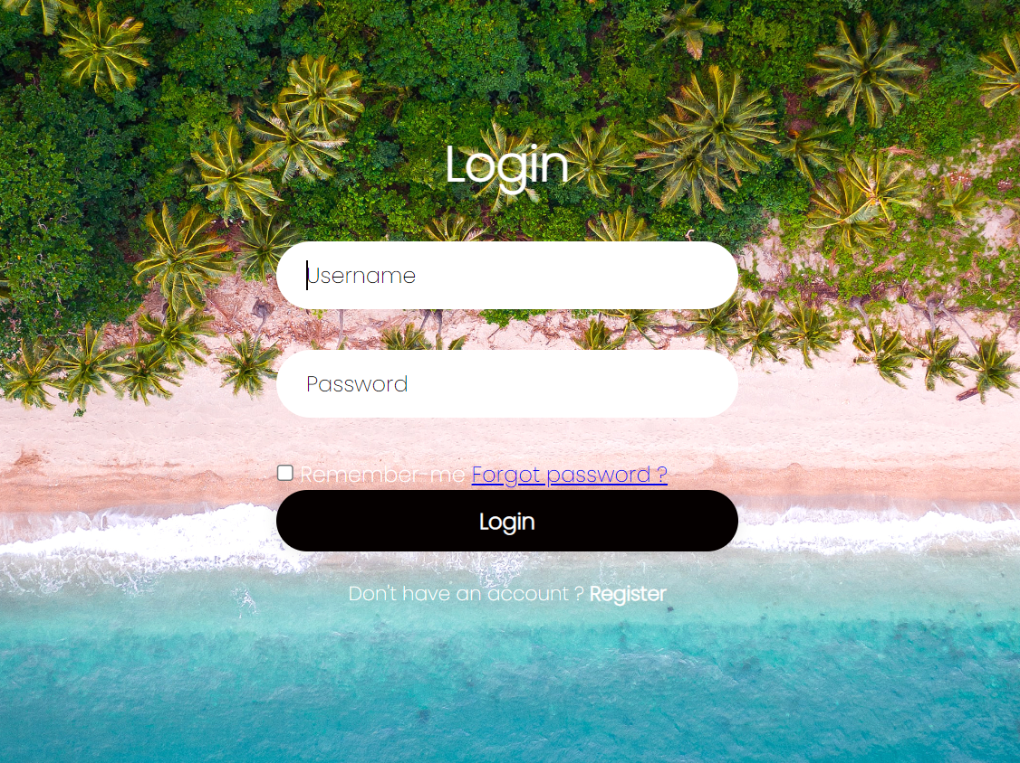

fig 3. : homepage

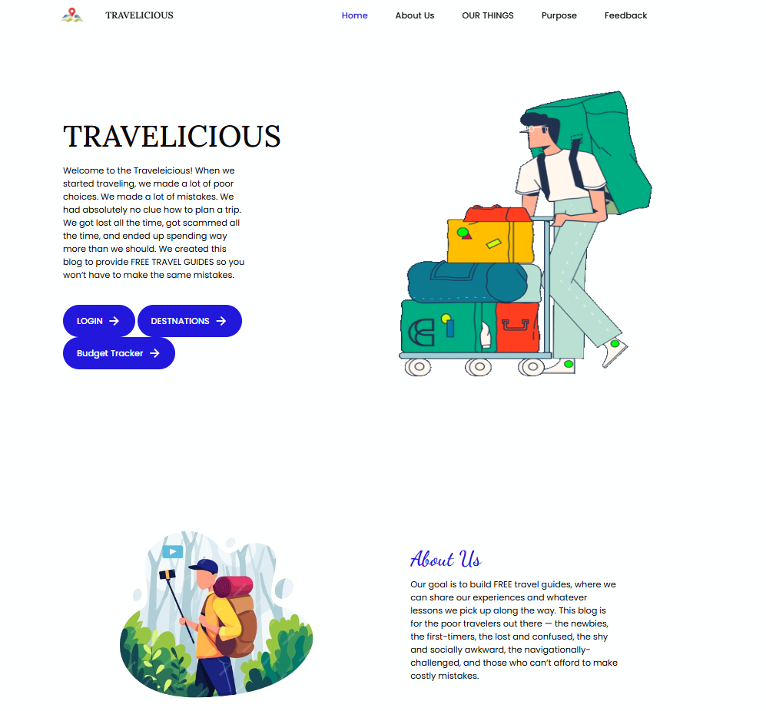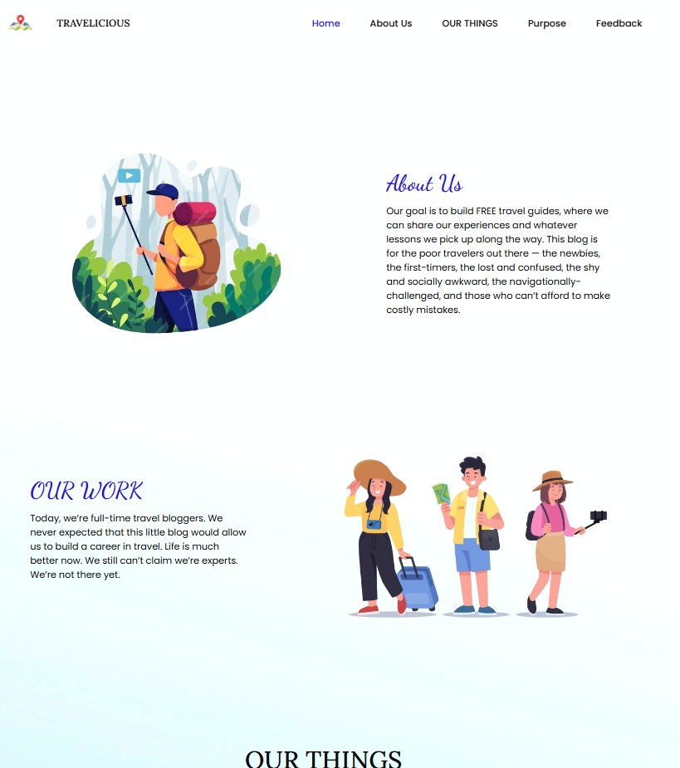

fig 5. : contact us page

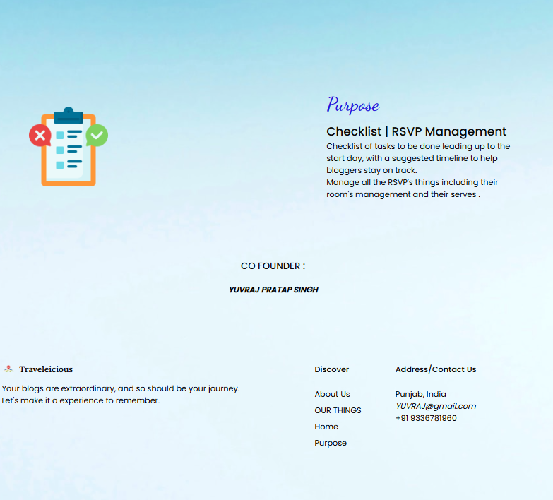

**GITHUB LINK :**

<https://github.com/aarohisingh06/html-project.git>